//DEEPIKA SHARMA -124959
ASSIGNMENT-6

6.1 Insert rows with the following data into the Customer table. 6000, John, #115 Chicago, #115 Chicago, M, 25, 7878776, 10000
• 6001, Jack, #116 France, #116 France, M, 25, 434524, 20000
• 6002, James, #114 New York, #114 New York, M, 45, 431525, 15000.50
Use parameter substitution.
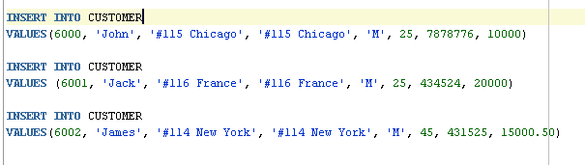

RESULT:-
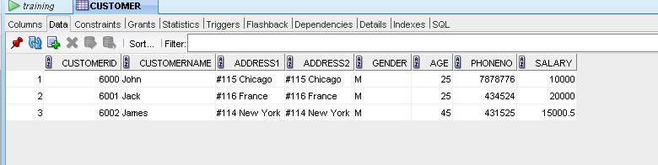

6.2 Create a Savepoint named ‘SP1’ after third record in the Customer table .
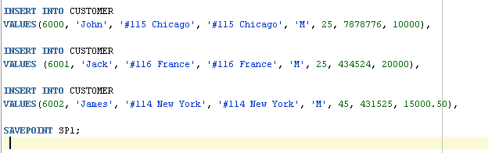
RESULT:-

6.3 Insert the below row in the Customer table.
6003, John, #114 Chicago, #114 Chicago, M, 45, 439525, 19000.60
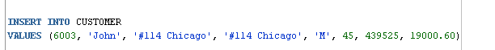

RESULT:-
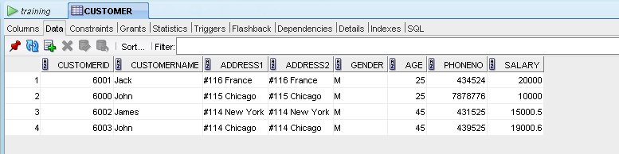

6.4 Execute rollback statement in such a way that whatever manipulations done before
Savepoint sp1 are permanently implemented, and the ones after Savepoint SP1 are not
stored as a part of the Customer table.
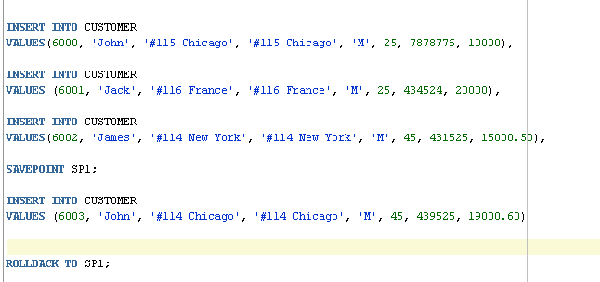

RESULT:-

